Task: Deploy a Sample Application on Tomcat Webapps

1. Outcome
Successfully deploy a sample web application in the Apache Tomcat webapps directory and access it through a web browser.

2. Objective
To learn how to deploy a sample application using a WAR file and verify that it is running on an Ubuntu virtual machine.

3. Prerequisites
- Ubuntu virtual machine installed in VMware.
- Java JDK installed.
- Apache Tomcat installed and running.
- Internet connection.
- Terminal access with sudo privileges.

4. Step-by-Step Implementation

1. Start Your Ubuntu VM
- Start your Ubuntu virtual machine.
- Log in to Ubuntu.
- Open the Terminal using Ctrl + Alt + T.

2. Verify Java Installation
Run the following command:
java -version
If Java is not installed, run:
sudo apt update
sudo apt install default-jdk -y

3. Check Apache Tomcat Status
Check whether Tomcat is running as a system service:
ps aux | grep '[o]rg.apache.catalina.startup.Bootstrap'
If Tomcat was installed manually, check its process:
ps aux | grep '[o]rg.apache.catalina.startup.Bootstrap'
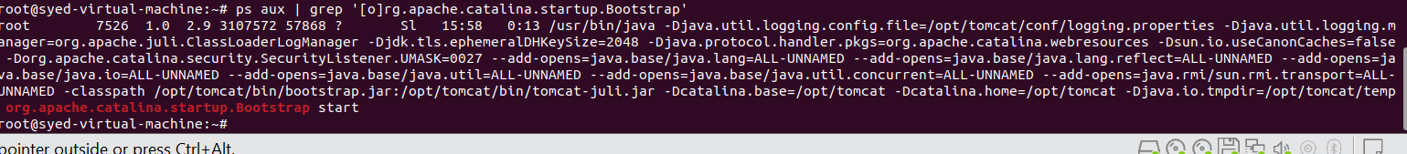
Check the port on which Tomcat is listening:
sudo ss -lntp | grep java
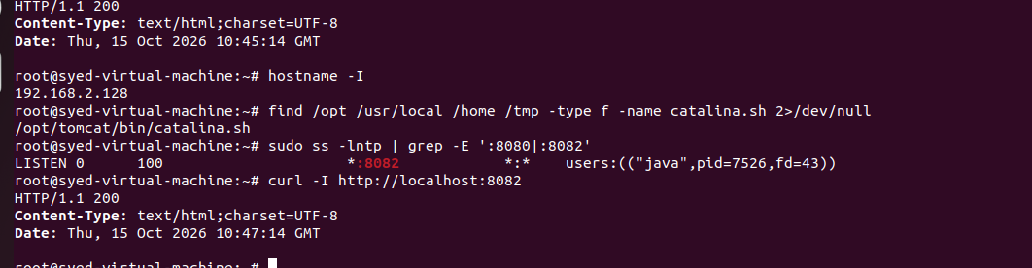
Note: Use your actual Tomcat installation directory and port. The examples below assume Tomcat is installed in /opt/tomcat and listens on port 8082.

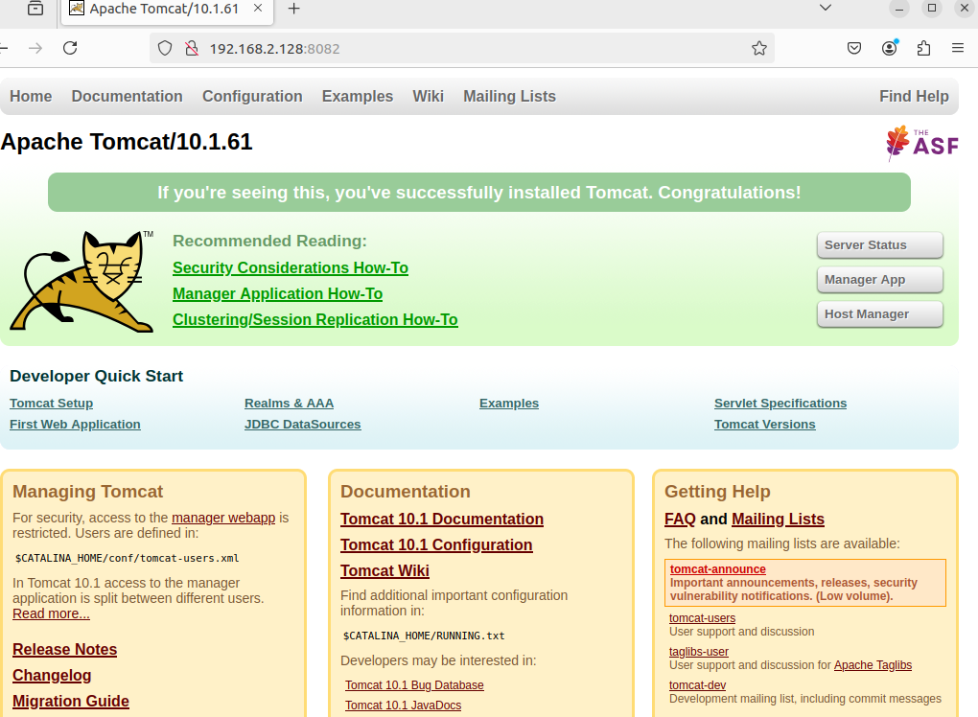

4. Navigate to the Webapps Directory
Run the following command:
cd /opt/tomcat/webapps
Verify the current directory:
pwd
Expected output:
/opt/tomcat/webapps
If your Tomcat installation is in another location, navigate to its corresponding webapps directory.
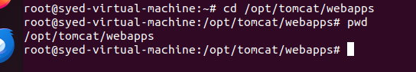

5. Download a Sample Application
Download the sample WAR file:
sudo wget https://tomcat.apache.org/tomcat-10.1-doc/appdev/sample/sample.war -O sample.war
Verify that the file was downloaded:
ls -lh sample.war

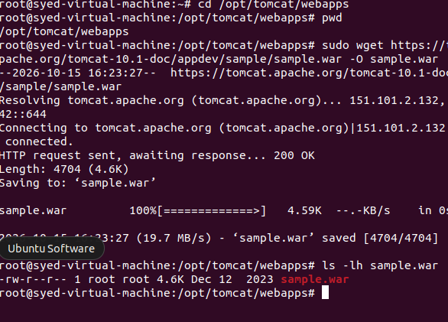

6. Set File Permissions
If your manually installed Tomcat runs under the tomcat user, run:
sudo chown tomcat:tomcat sample.war
sudo chmod 644 sample.war
If Tomcat runs under a different user, use the appropriate username and group.

7. Deploy the Application
Tomcat normally deploys WAR files automatically when automatic deployment is enabled.
Check the contents of the directory:
ls -l
After deployment, you may see:
sample.war
sample/
The sample/ directory contains the extracted application files.
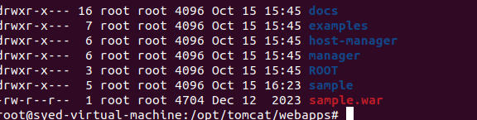

8. Verify the Application
Run the following command:
curl -I http://localhost:8082/sample/
Replace 8082 with your actual Tomcat port.
Expected result:
HTTP/1.1 200
A successful HTTP response indicates that the application is responding.
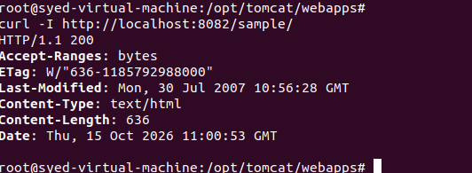

9. Open the Application in a Browser
Open Firefox in Ubuntu and enter:
http://localhost:8082/sample/
If Tomcat uses port 8080, enter:
http://localhost:8080/sample/
The sample application should appear if deployment is successful.
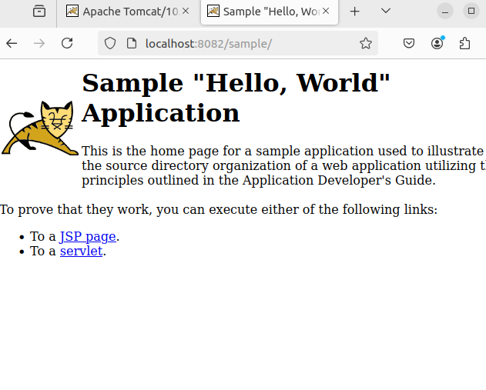

10. Check the Ubuntu IP Address
Run:
hostname -I
Example output:
192.168.2.128
To access the application from another computer on the same network, use:
http://192.168.2.128:8082/sample/
Replace the example IP address with your actual Ubuntu IP address.

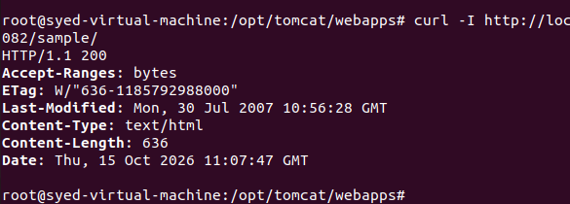6. Expected Final Result
The sample application should be deployed successfully and accessible at:
http://localhost:8082/sample/
Troubleshooting: If you receive 404 Not Found, check the WAR file, Tomcat logs, deployment status, and compatibility with your Tomcat version. Tomcat 10.1 applications generally require Jakarta EE 10-compatible APIs.

